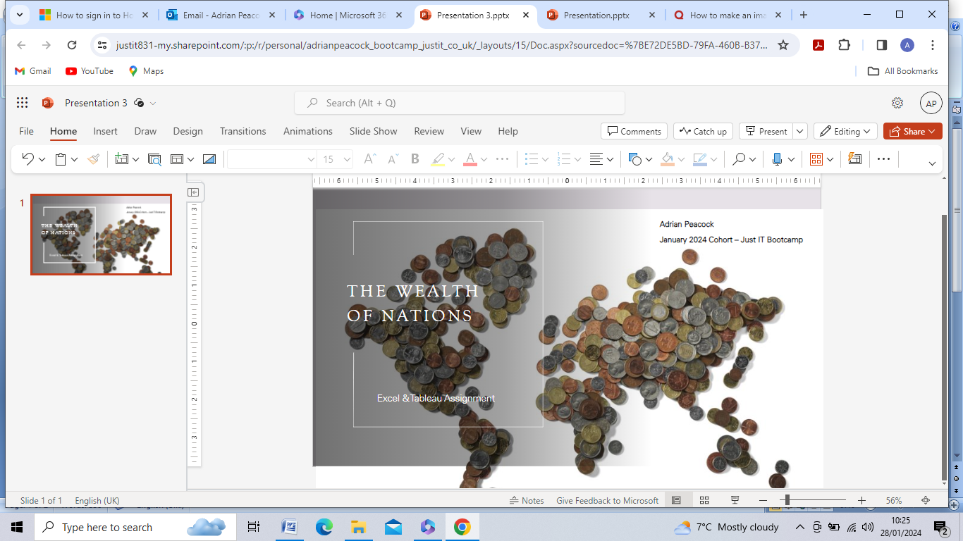

**About the Author**

The Author of this report, **Adrian Peacock**, is a student participating in the Data Technician Skills Bootcamp as a trainee Data Analyst.with the training group JUST IT TRAINING LIMITED.

**About the Client**

The Client of this Report is:

**“JUST IT TRAINING LIMITED”** (a subsidiary of Back2Work Group[1]).

The firm’s auditors, in identifying and assessing potential risks the Client’s business faces, have had to consider:

*‘ ... the legal and regulatory framework in which the Company operates, particularly those laws and regulations which have a direct effect on the financial statements ... including General Data Protection requirements ...”.*

These requirements, especially the need for the Author to ensure they are complied with in this Report, are examined further below. It is important to ensure compliance as non-compliance can result in penalties and legal action as well as reputational damage.

**Introduction to the Wealth of Nations Data Visualisation Report:**

**The Brief for this Report**

The Client requires the Author:

*“ ...to create a visual report that will show the (Excel) dataset in the form of charts and maps using Tableau ...”*

**Scenario**

Data visualisation is now a crucial corporate tool for turning data into insights that can lead to better experiences and significant financial results. Nowadays, the majority of companies have amassed a plethora of data from the various areas of their operations they are then blind to the ways in which this data might improve their choices, behaviours, and outcomes.

The Client has therefore requested that the Author of this Report looks over the data workbook provided and becomes acquainted with the information in it. Additionally, the Author has been asked to use Tableau to generate a visual Report that meets the Client’s expectations, by displaying the data as charts and maps. Policies regarding computer misuse and data protection must also be taken into consideration by the Author, these policies are addressed in the next section:

**Policies and Procedures**

As a data analyst the Author has to acknowledge and follow data security and protection policies and procedures. This is particularly so when dealing with sensitive or personal information. This ensures the safeguarding of data security, privacy, and compliance. Before processing data the Author must demonstrate awareness of the policies and procedures of:

1. the Client
2. the statutory framework
3. **Company policies and procedures**

The Client’s Privacy Policy[2] sets out its policies and expectations on data privacy and protection:

*“ ... Just IT must comply with the UK Data Protection Act, 1998, GDPR, 2018, and equivalent legislation. These laws requires Just IT to protect personal information and control how it is used in accordance with the legal rights of the data subjects – the individuals whose personal data is held ... This policy and its supporting procedures and guidance aim to ensure that Just IT complies with its obligations as a Data Controller under the UK Data Protection Act, 1998 and GDPR, 2018, and processes all personal data in compliance with the Data Protection Principles which are set out in the Act ...”*

The Client’s Privacy Policy applies to learners and candidates enrolled on its Bootcamps, including the Author, who must be able to demonstrate and awareness of the Policy:

*“ ... Just IT will ensure that our learners and candidates are aware of how privacy law applies to their use of personal data in the course of their studies and how they can take appropriate steps to protect their own personal data and respect the privacy of others ...”*

1. **Statutory Policies and Procedures**

Underpinning the Client’s Privacy Policy is the statutory framework mentioned in the extracts above. The most important national policy a data analyst must have regard to is the **Data Protection Act 2018**[3], this represents the UK's adoption of the European General Data Protection Regulation (GDPR). The 2008 Act remains in force despite Brexit; it is likely to remain so, as the handling of sensitive data must continue to be compatible with international standards. Individuals tasked with handling personal data are obligated to adhere to stringent guidelines known as "data protection principles"[4]. There are seven key principles set out by the UK’s Information Commissioner’s Office (ICO):

1. Lawfulness, fairness and transparency
2. Purpose limitation
3. Data minimisation
4. Accuracy
5. Storage limitation
6. Integrity and confidentiality (security)
7. Accountability

These principles ensure that information must be utilized by analysts:

* Fairly, lawfully, and transparently;
* For explicitly-stated purposes.
* In a manner that is sufficient, relevant, and limited to the necessities.
* Maintained accurately and, when applicable, kept up-to-date.
* Retained only for the duration required.
* Handled securely, encompassing protection against unauthorized processing, access, loss, destruction, or damage.

Article 5(2) of the GDPR regulations adds a crucial additional requirement for the data analyst, who must not only implement the preceding six key principles, but be at all times able to demonstrate his or her compliance with them; this is known as the principle of ‘accountability’, it represents the seventh of the key principles.

Enhanced legal safeguards are in place for particularly sensitive information, known as ‘special category data[5]’, these special categories include data concerning or referencing the personal attributes of individual or group data subjects such as their: race, ethnic background, political opinions, religious beliefs, trade union membership, genetics, biometrics (if employed for identification), health, and details regarding their sex lives or sexual orientation. These principles are indispensable for data protection, legal compliance, for building trust, and for mitigating risks.

Organizations can ensure responsible and secure data utilization by implementing guidelines that treat data as a valuable asset. Failure to adhere to a data handling policy may result in legal, financial, and reputational consequences. Therefore, upholding these principles is not just a legal requirement but a means of fostering trust and safeguarding against potential repercussions. These principles have been adhered to by the Author in preparing this report to protect the Client.

**The Risks of Non-Compliance**

Under Data Protection Act 2018 (‘GDPR’), organisations who fail to comply and/or suffer a data breach could face a fine. In the most serious cases, this fine could be up to 17 million euros, or 4% of a company’s annual turnover. This upper limit far exceeds the previous maximum fine of £500,000 allowed under the Data Protection Act 1988 (no repealed). An even bigger ramification of failing to comply with GDPR is the damage to a company’s reputation, which can sometimes be beyond repair.

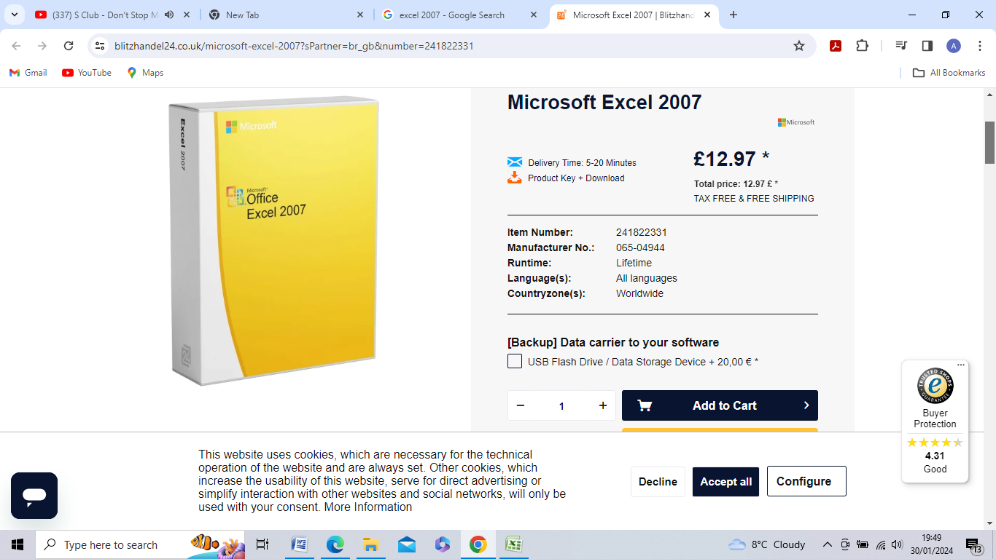**Notes on the tools used to prepare and present this Report**

**Excel 2007**

Excel 2007 is a significantly out-dated version of Microsoft’s Excel software suite.

Nevertheless, Excel 2007 is the first version of Excel featuring the ‘Ribbon’ functionality and appears as part of the original Microsoft Office, the current version of which is Microsoft 365.

All references to Excel and screenshots are taken from the Excel 2007 package unless otherwise stated. Any limitations are referred to in the text.

**Opening and manipulating the dataset in Excel**

1. **Setting a password to protect the workbook:**

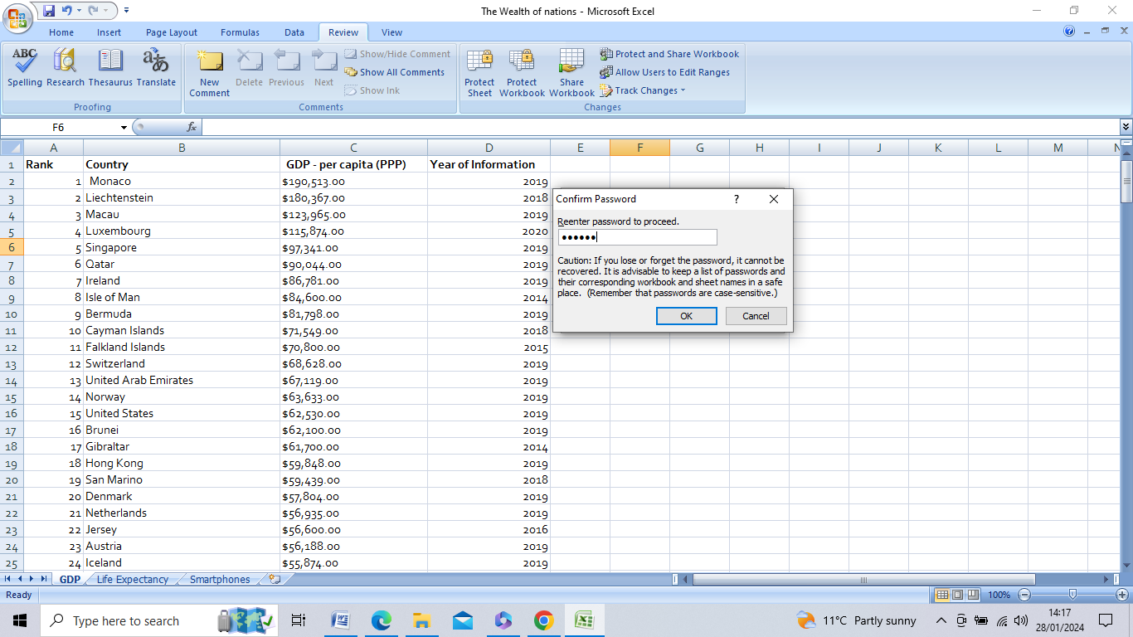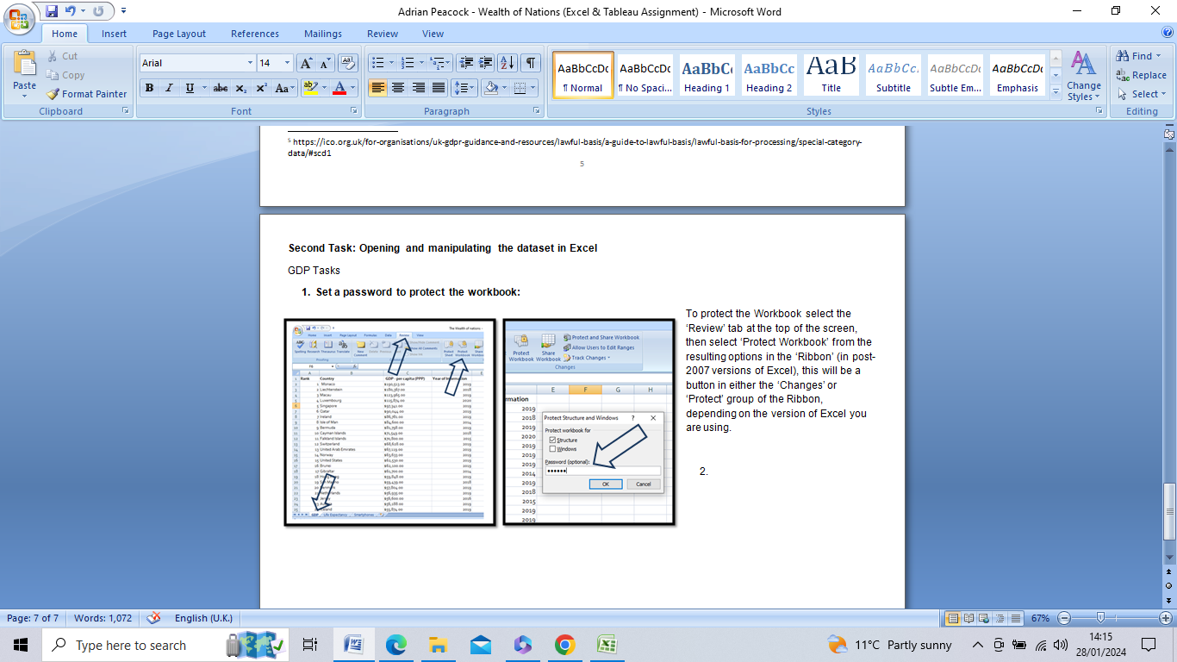To protect the Workbook I selected the ‘Review’ tab at the top of the screen, then I selected ‘Protect Workbook’ from the resulting options displayed in the ‘Ribbon’, a button in either the ‘Changes’ or ‘Protect’ group of the Ribbon, depending on the version of Excel used. In the pop-out box ‘Protect Structure and Windows’ I typed in a password and, keeping ‘Structure’ selected, I pressed ‘OK’. I was prompted to re-enter the password to confirm it, and warned that the password must be stored securely as it cannot be recovered within the system if I forget it.

Once the Workbook is protected it is not possible, without the password being entered, to then delete or alter the Workbook, options to Delete, Rename, Move or Copy the Workbook are consequently greyed out.

1. **Highlighting Column C and change the data to display in British Pound symbol (£):**

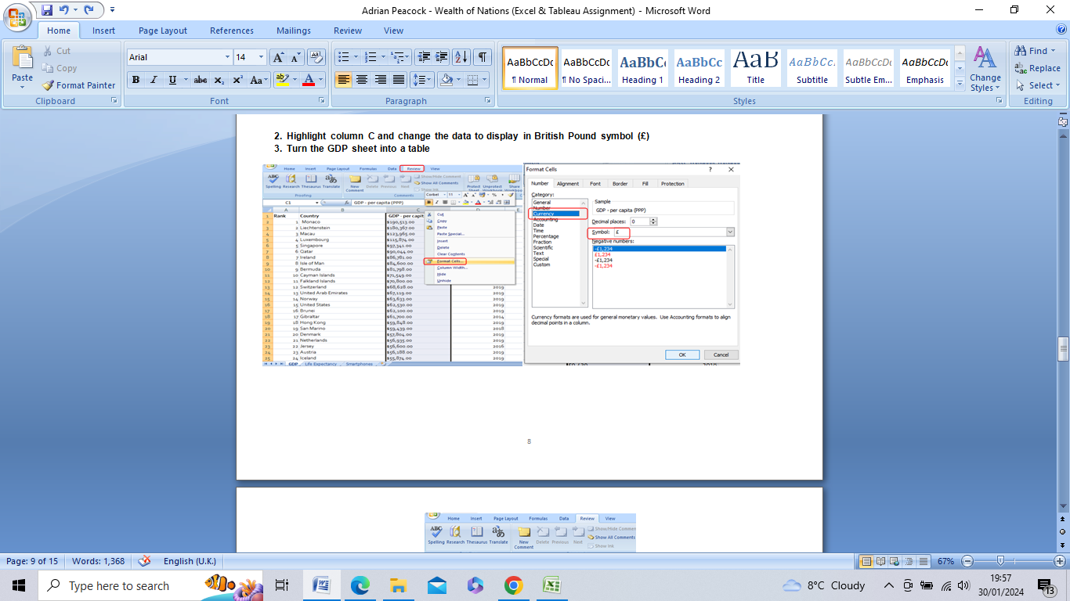

I clicked on Column C to highlight it and Right-Clicked to access the “Format Cells” option. In Format Cells I altered the Format to “Currency” and then Symbol “£” from the drop down menu.

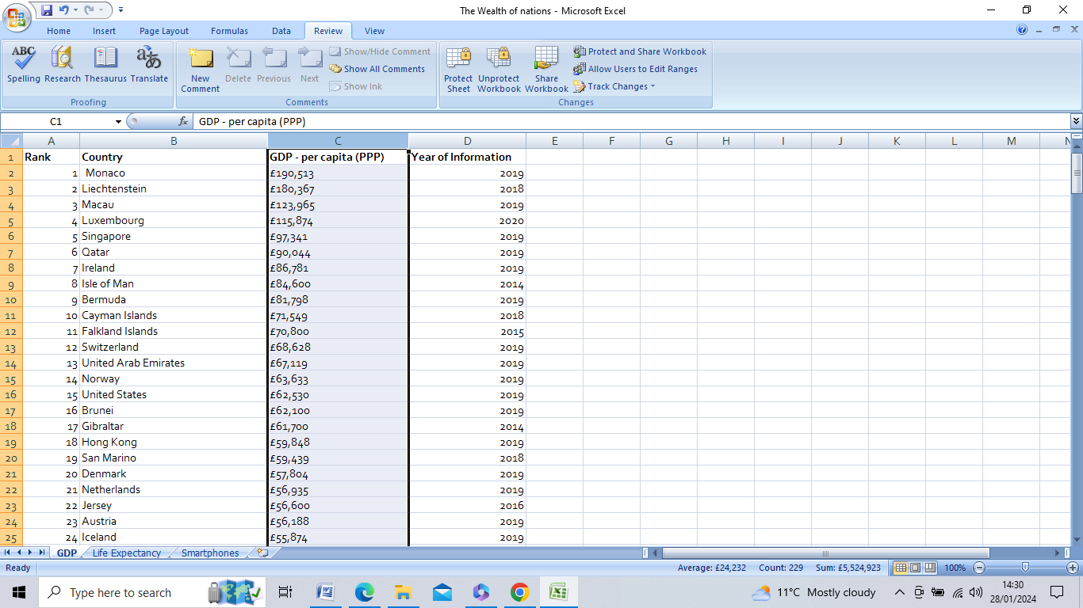

1. **Turning the GDP sheet into a table:**

I initially turned the GDP data-set into an orange-coloured table. This was altered later in the project. I highlighted the Columns in the data and selected the Design Tab in the Ribbon to bring up Table Tools options (I selected a style featuring Banded Rows and a Header Row).

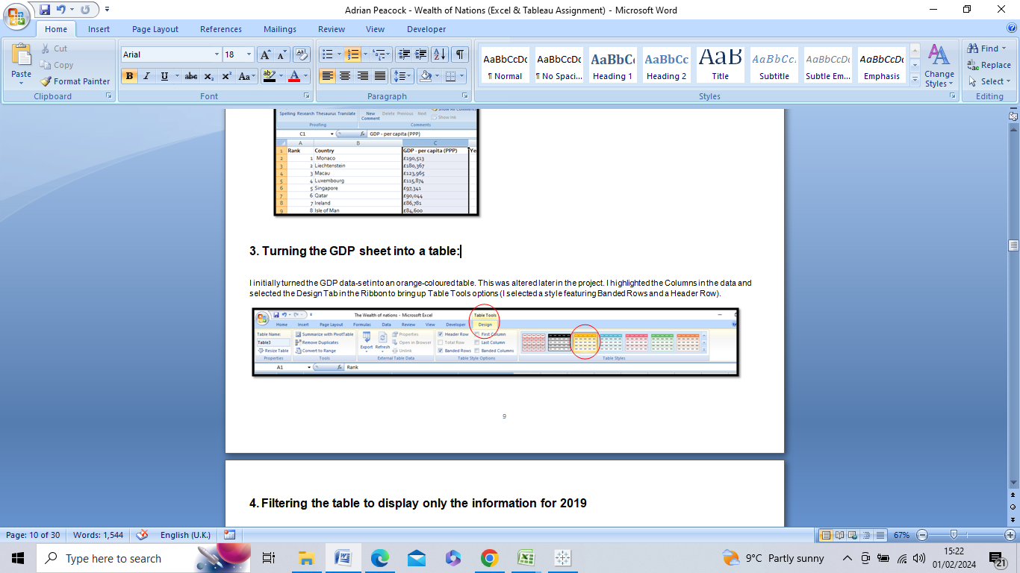

1. **Filtering the table to display only the information for 2019**

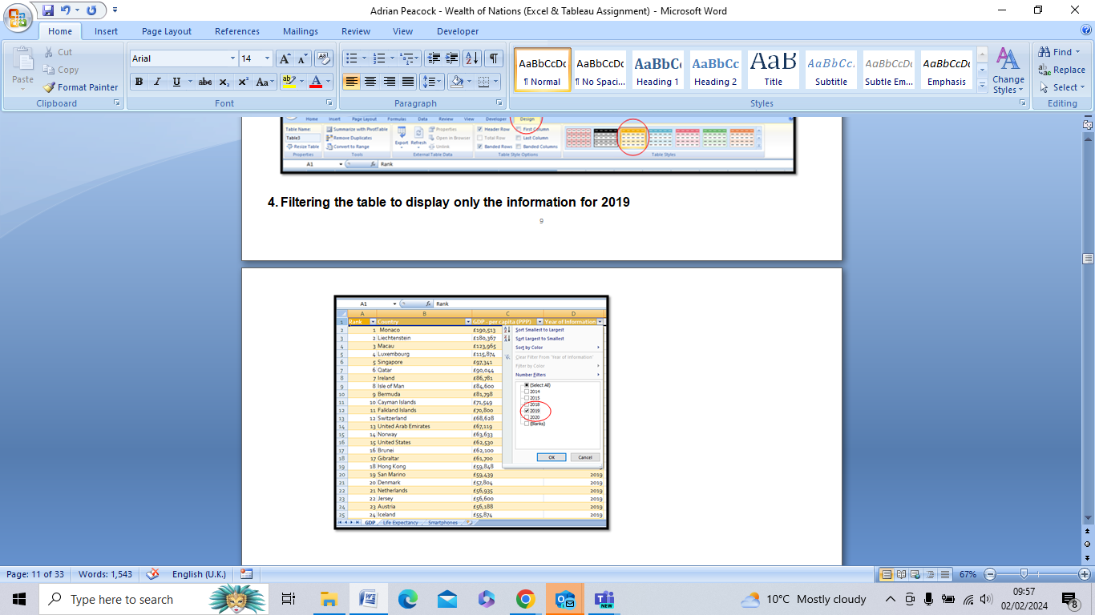

1. **Creating a suitable chart only displaying the data:**

**‘Rank’; ‘Country’; ‘GDP - per capita (PPP)’** 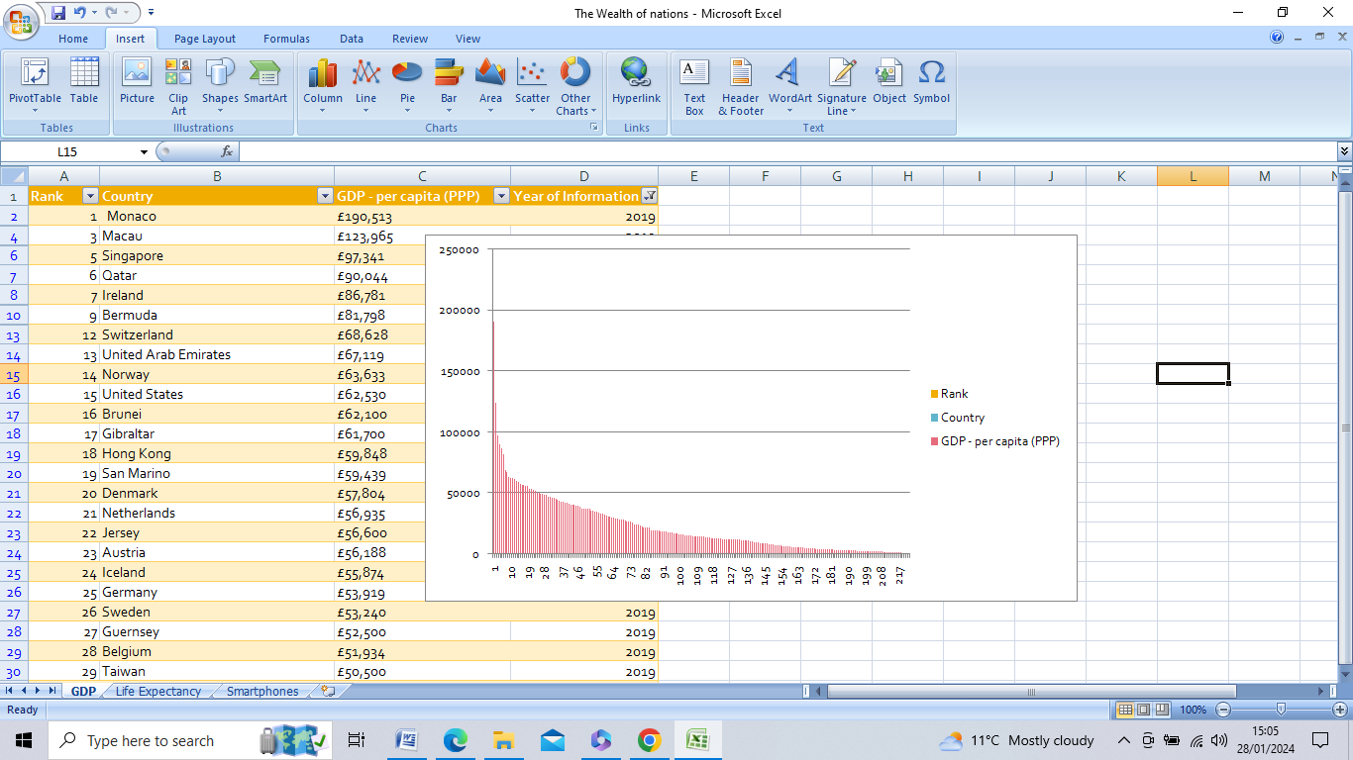

1. **Adding a Chart Title; “X” and “Y” Axis labels; and making the Chart visually pleasing:**

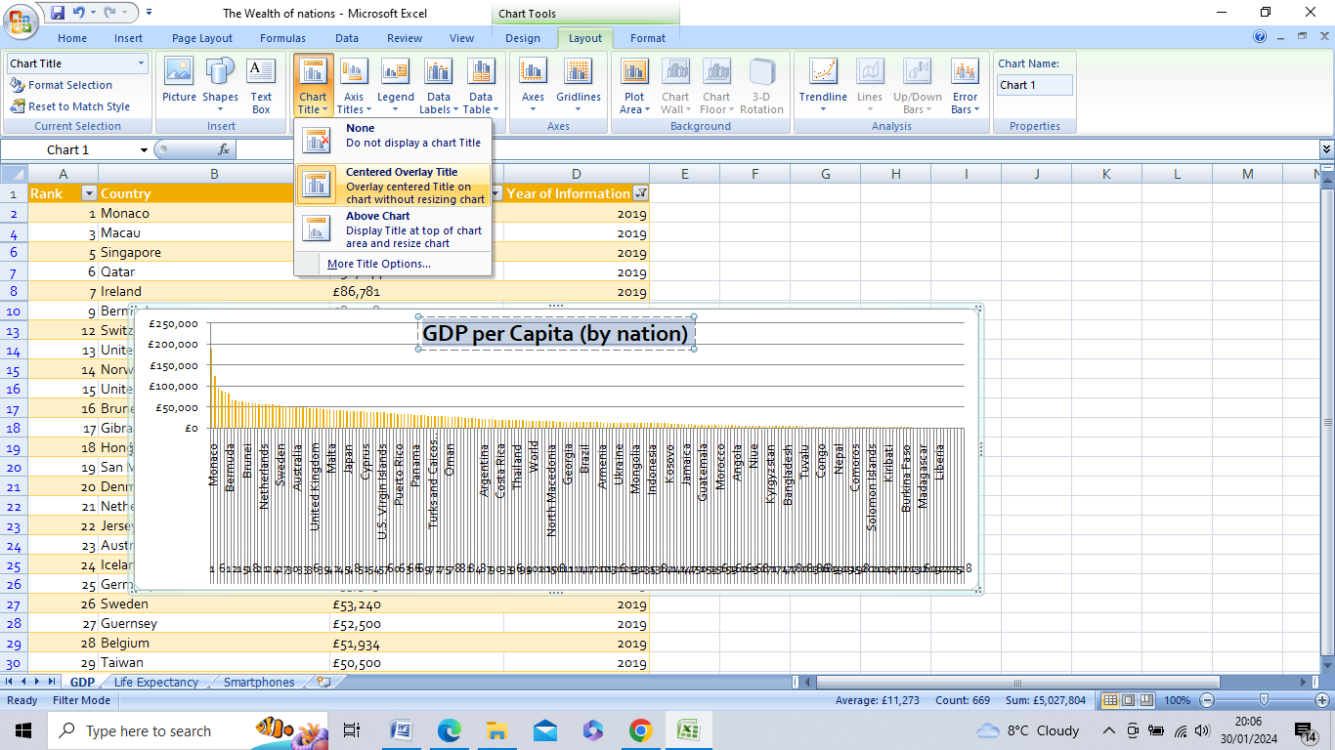

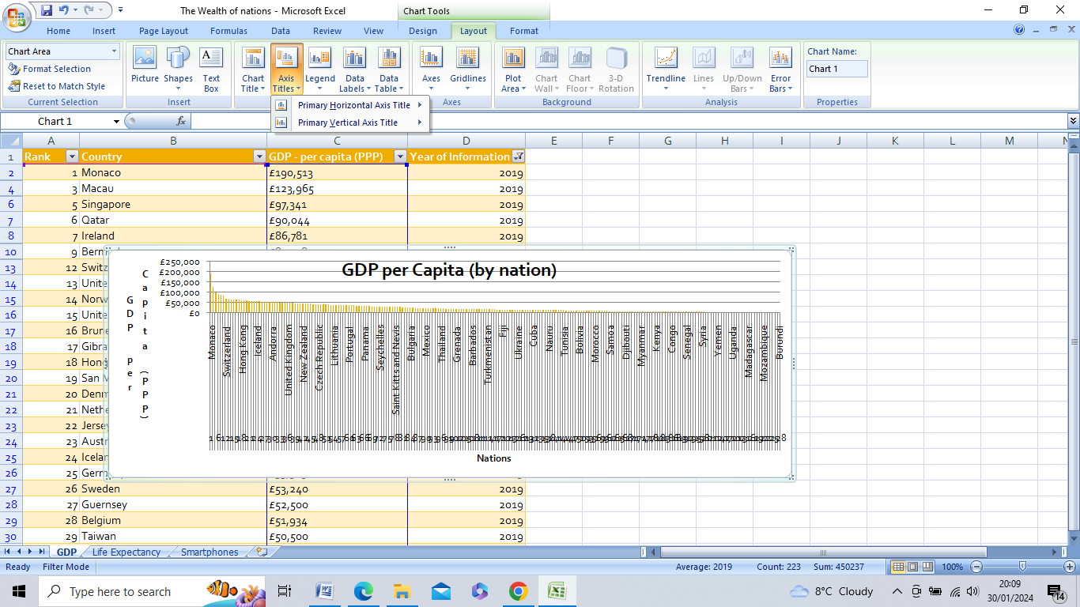

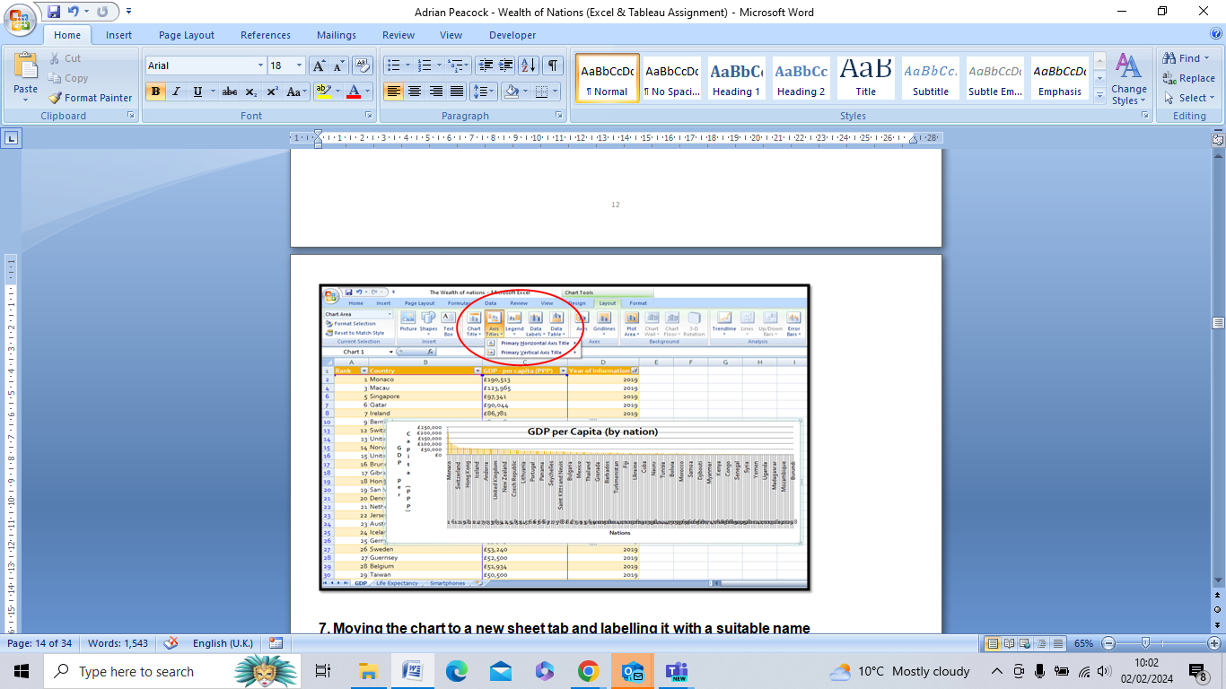

1. **Moving the chart to a new sheet tab and labelling it with a suitable name**
2. **Sorting for the top 20 highest ranking Countries**

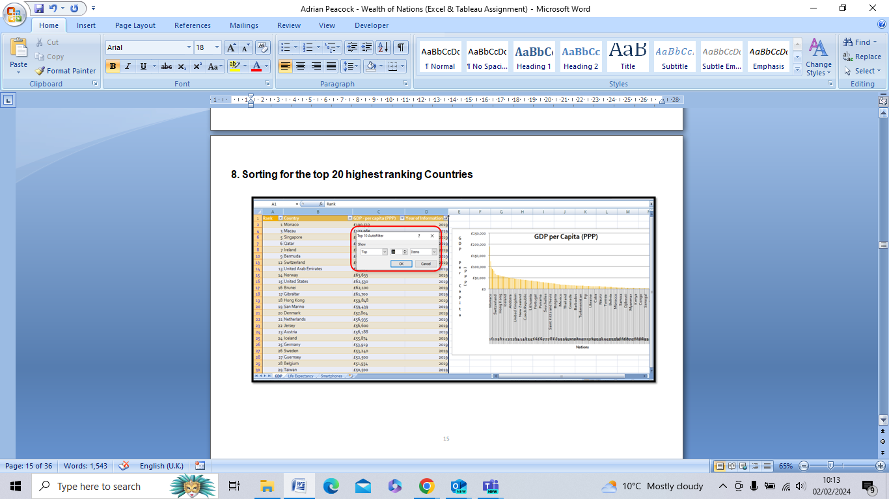

1. **A new Bar chart displaying the 20 highest ranking Countries from the sort (with the Bar Chart moved underneath the table).**

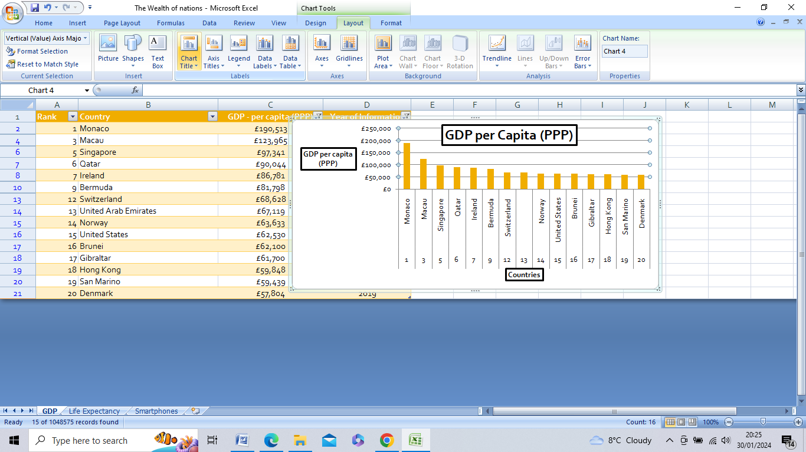

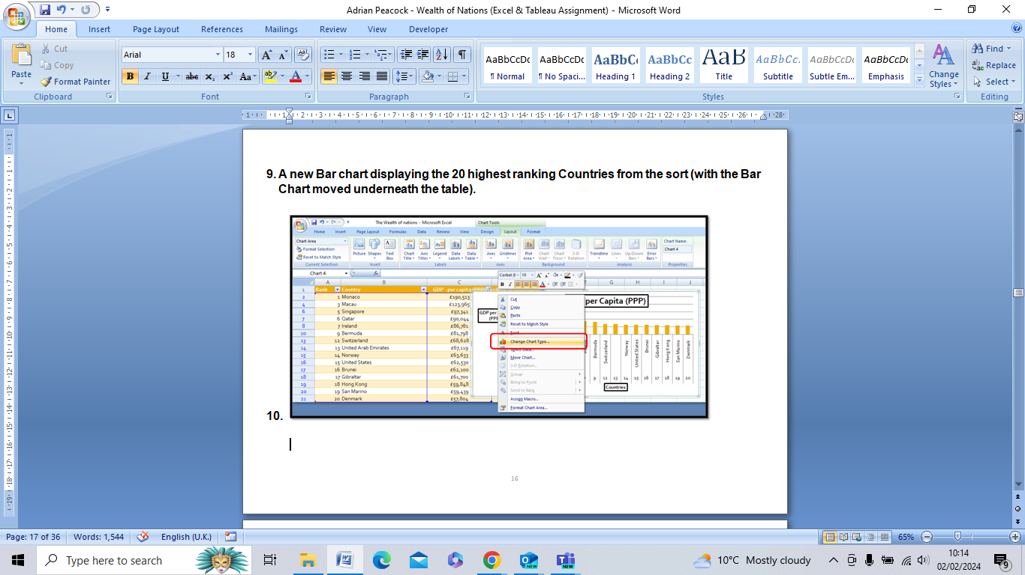

1. With the Chart altered to a Bar Chart the data display is complimented with macro-enabled Buttons which enable the Client to ‘Print’, ‘Copy’ and ‘Save’ the worksheet in Excel. The finished presentation is also then saved to a Word document. This document is then as ‘Word Gross domestic product report 1’

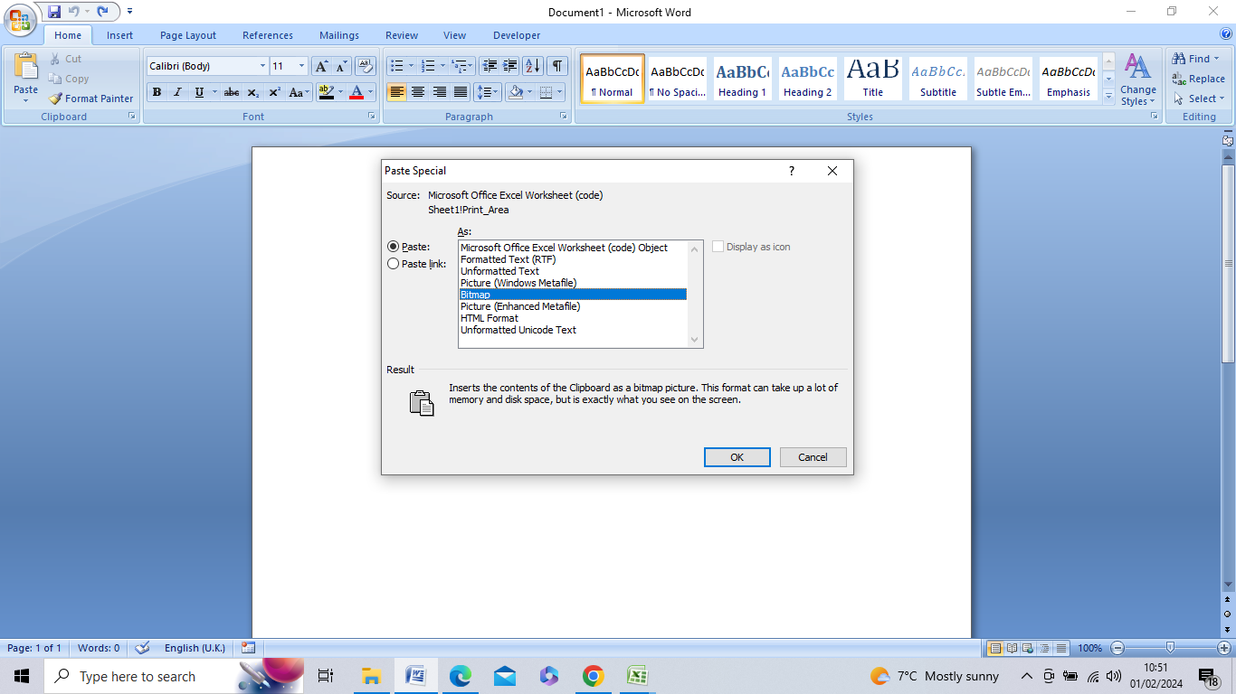

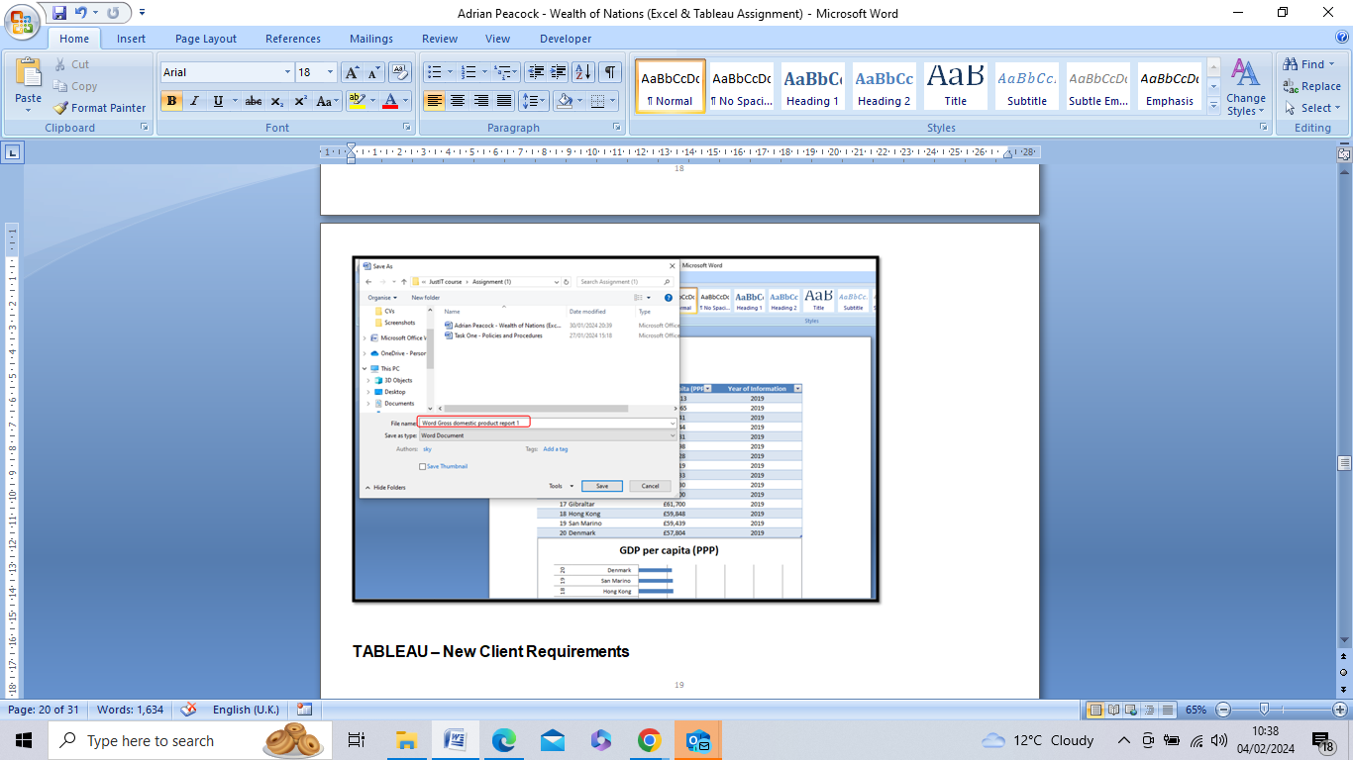

**Please refer to the accompanying documents:**

* Excel Gross domestic product report 1.xlxs
* Word Gross domestic product report 1.doc

**TABLEAU – New Client Requirements**

The Client is colour-blind and requests the Author to bear this in mind when building a Tableau dashboard. The client is only interested in the top 20 highest ranking countries. All visuals should be for the top 20 highest ranking countries.

Some screen shots of the construction of the Tableau Dashboard and importation and linking of data are included below. The full Workbook and Dashboard can be viewed at the link below:

[**Assignment 1 Data Visualisation | Tableau Public**](https://public.tableau.com/app/profile/adrian.peacock/viz/Assignment1DataVisualisation_17070535385020/GDPDashboard?publish=yes)

Continuing with the Excel table ‘The Wealth of nations’ in Tableau to produce a report and Dashboard: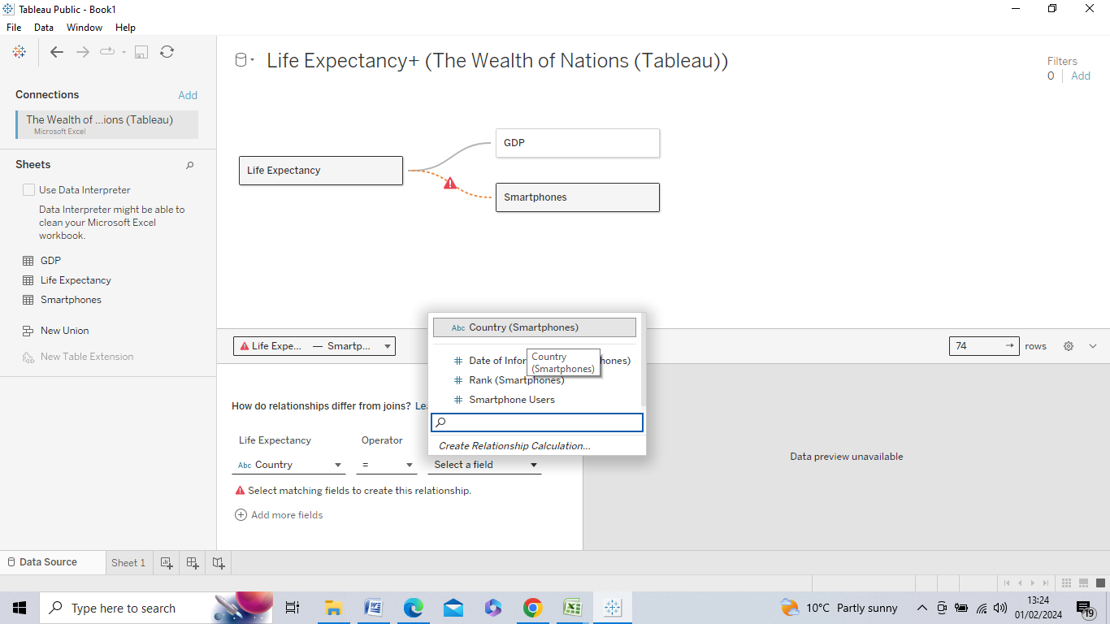

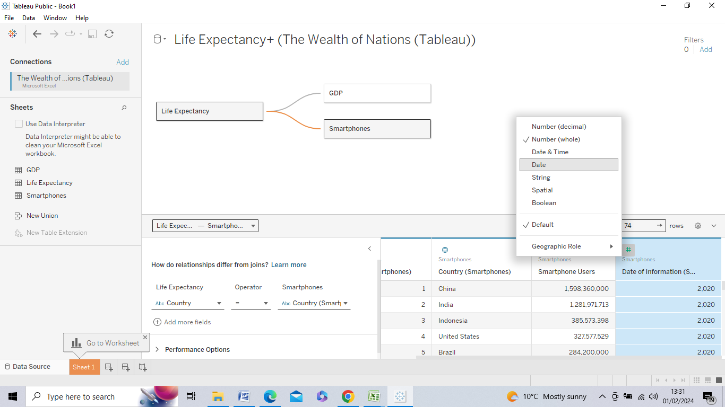

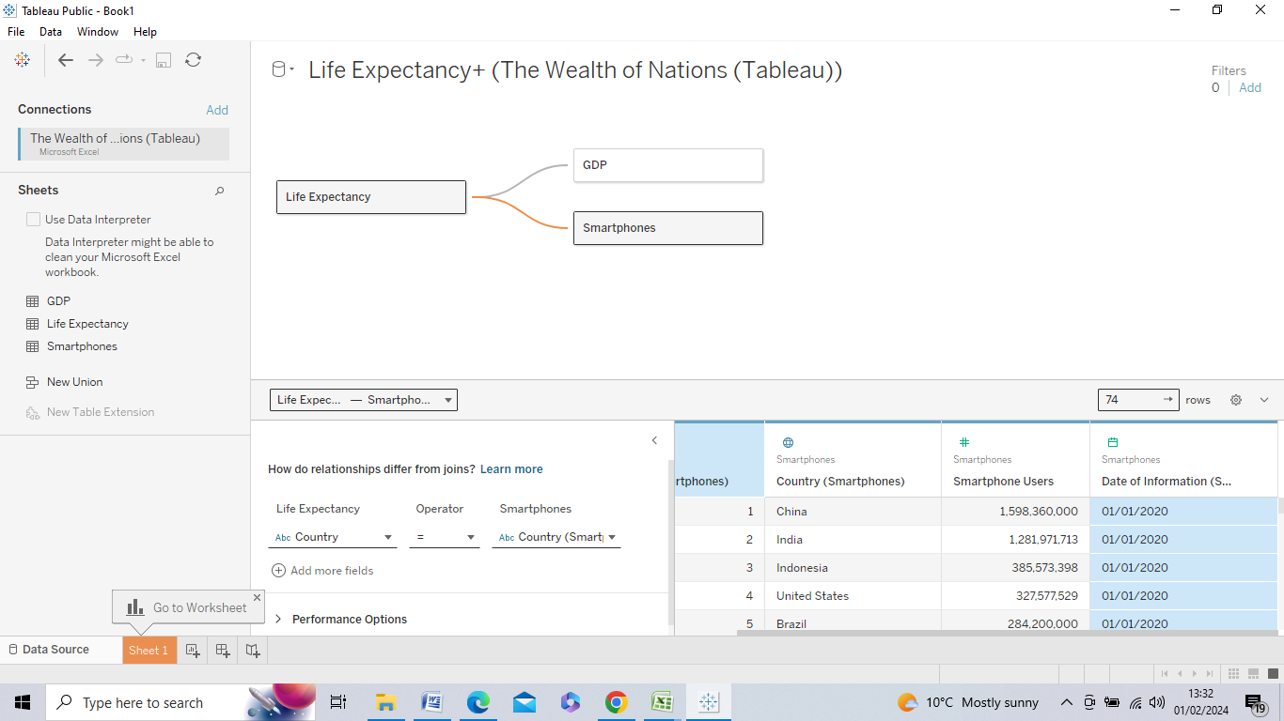



**TABLEAU – Setting the Colour Palette to accessible for ‘Colour Blind’:**

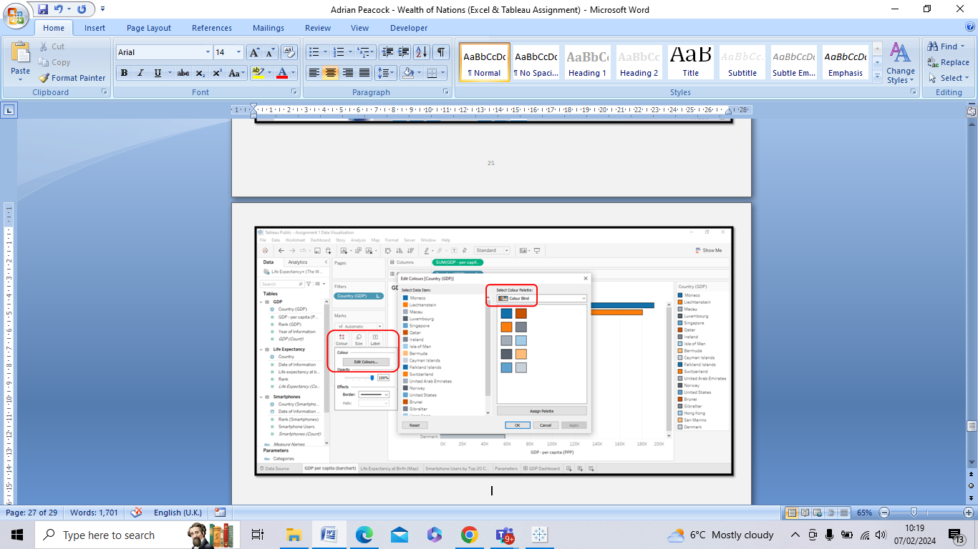

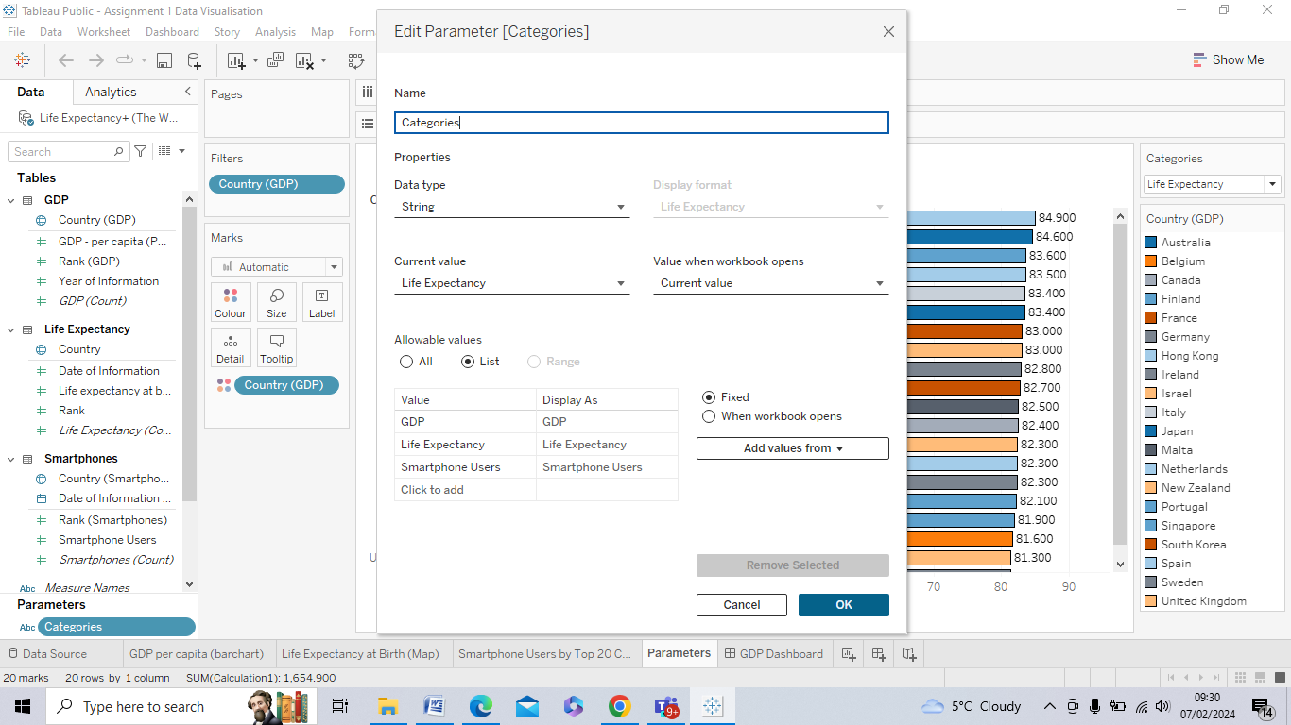

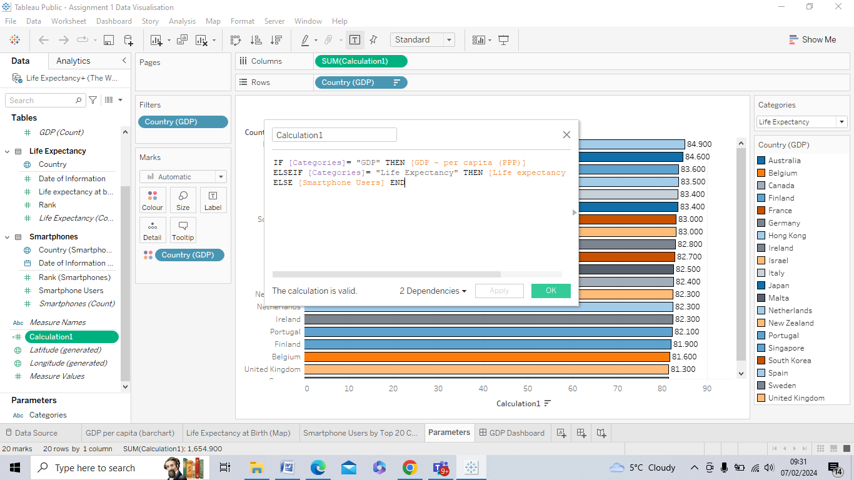

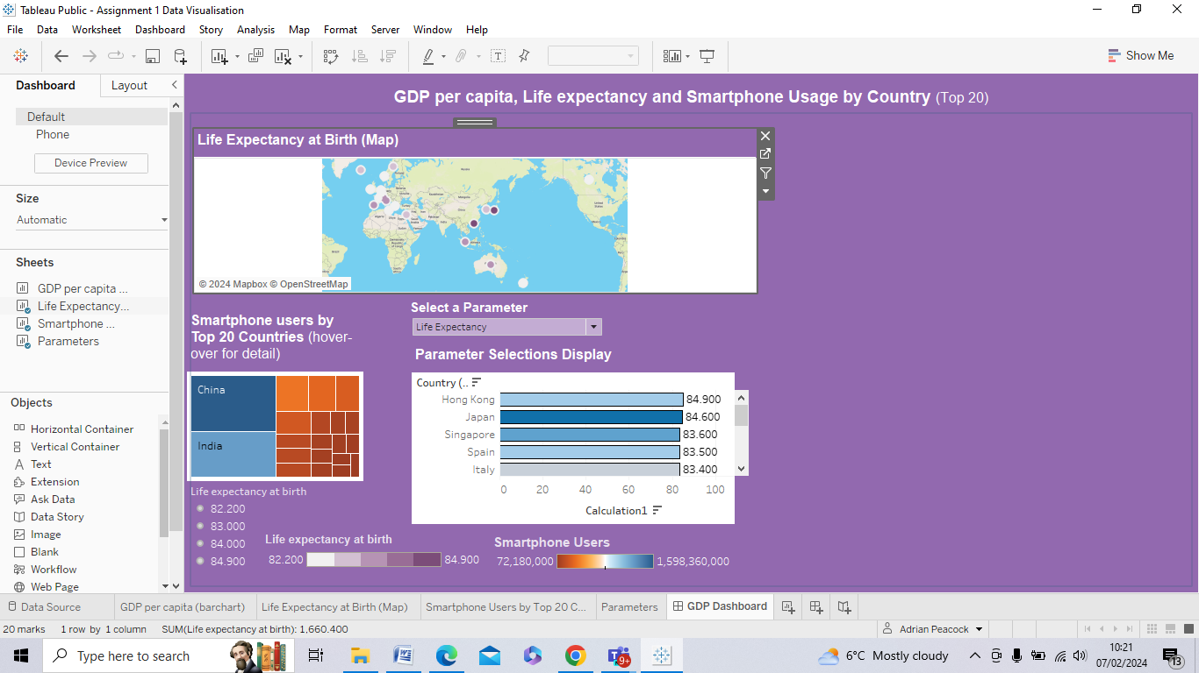

1. According to its Annual Accounts, Back2Work Group acquired JUST IT TRAINING LIMITED in June 2022. JUST IT TRAINING LIMITED is funded by the Education and Skills Funding Agency (ESFA).
2. https://www.justit.co.uk/privacy-policy/#:~:text=3.2%20Process%20personal%20data%20fairly,Protection%20Act%20and%20GDPR%20legislation.
3. https://www.legislation.gov.uk/ukpga/2018/12/contents/enacted
4. https://ico.org.uk/for-organisations/uk-gdpr-guidance-and-resources/data-protection-principles/a-guide-to-the-data-protection-principles/
5. https://ico.org.uk/for-organisations/uk-gdpr-guidance-and-resources/lawful-basis/a-guide-to-lawful-basis/lawful-basis-for-processing/special-category-data/#scd1